**AIM: Design UI based applications using basic Windows forms Controls**

1. **Write a Program in C# that ask the user to enter a month, a day and a two digit year. The program should then determine whether the month times a day is equal to the year. If so, it should display the message saying the date is magic. Otherwise not a magic.**

**SOURCE CODE:**

using System;

using System.Collections.Generic;

using System.ComponentModel;

using System.Data;

using System.Drawing;

using System.Linq;

using System.Text;

using System.Threading.Tasks;

using System.Windows.Forms;

namespace p1MagicNumber

{

public partial class Form1 : Form

{

public Form1()

{

InitializeComponent();

}

private void button1_Click(object sender, EventArgs e)

{

int month = Convert.ToInt32(numericUpDown1.Text);

int date = Convert.ToInt32(numericUpDown2.Text);

int year = Convert.ToInt32(numericUpDown3.Text);

if (date * month == year)

{

MessageBox.Show("Date is a magic date", "MagicNumberCheck");

}

else

{

MessageBox.Show("Date is not a magic date", "MagicNumberCheck");

}

}

}

}

**OUTPUT:**

**CASE-I:**

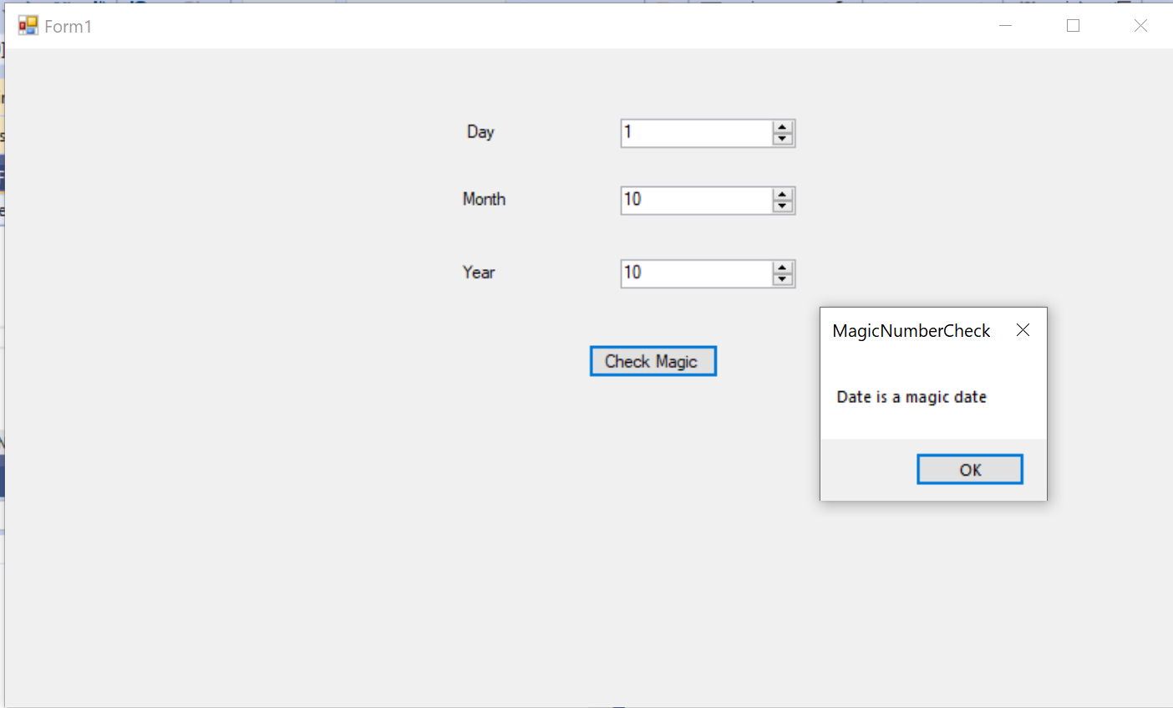

**CASE-II:**

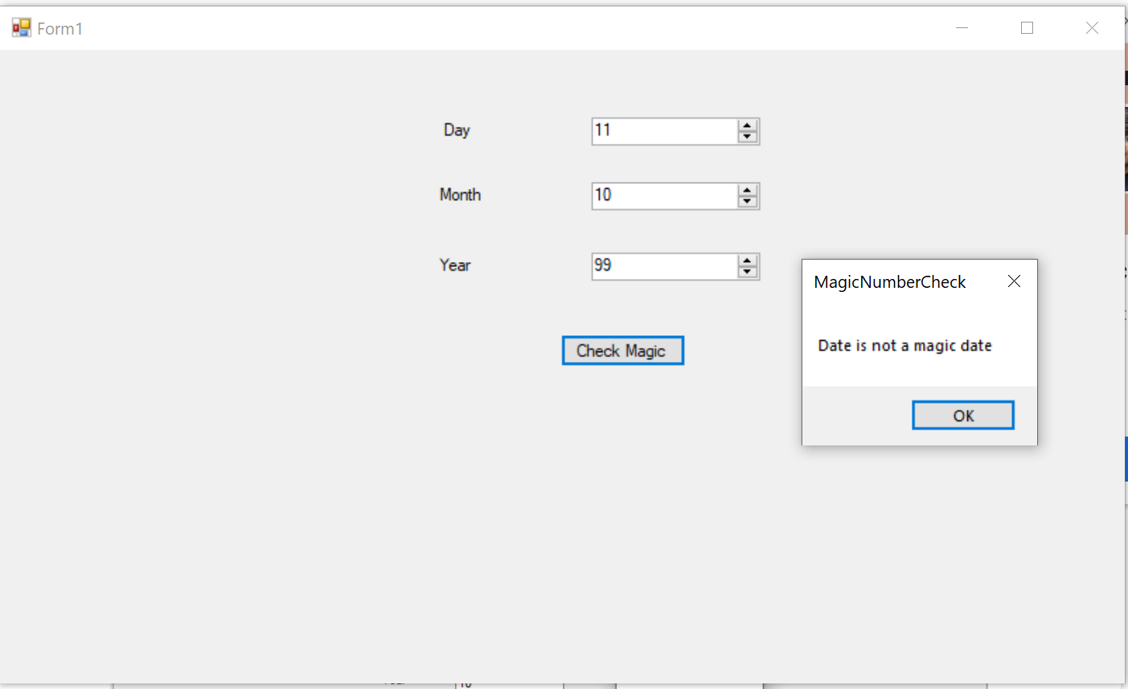

1. **Write a Program to perform Money Conversion.**

**SOURCE CODE:**

using System;

using System.Collections.Generic;

using System.ComponentModel;

using System.Data;

using System.Drawing;

using System.Linq;

using System.Text;

using System.Threading.Tasks;

using System.Windows.Forms;

namespace p1MagicConversion

{

public partial class Form1 : Form

{

public Form1()

{

InitializeComponent();

}

private void button1_Click(object sender, EventArgs e)

{

int amt = Convert.ToInt32(textBox1.Text);

double value = 0;

if (comboBox1.Text == comboBox2.Text)

{

MessageBox.Show("Conversion Formats can't be same", "Money Conversion");

}

else if (comboBox1.Text == "INR" && comboBox2.Text == "USD")

{

value = amt * 0.013;

}

else if (comboBox1.Text == "INR" && comboBox2.Text == "EUR")

{

value = amt * 0.012;

}

else if (comboBox1.Text == "USD" && comboBox2.Text == "INR")

{

value = amt * 77.42;

}

else if (comboBox1.Text == "USD" && comboBox2.Text == "EUR")

{

value = amt * 0.95;

}

else if (comboBox1.Text == "EUR" && comboBox2.Text == "INR")

{

value = amt * 81.96;

}

else if (comboBox1.Text == "EUR" && comboBox2.Text == "USD")

{

value = amt * 1.05;

}

MessageBox.Show(amt + " " + comboBox1.Text + " = "+value.ToString("0.00") +" "+ comboBox2.Text, "Money Conversion");

}

}

}

**OUTPUT:**

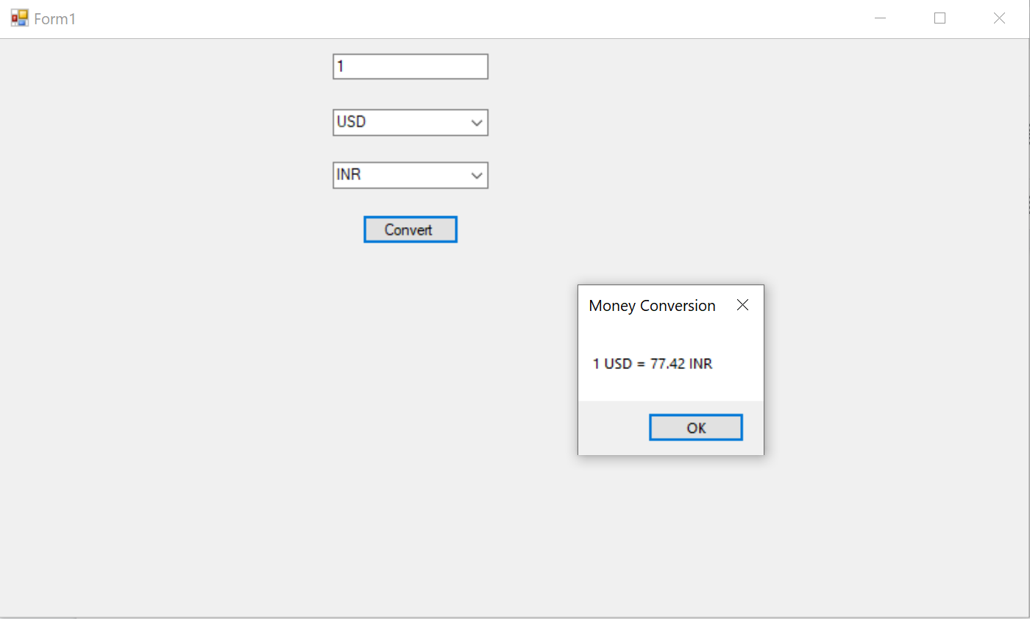

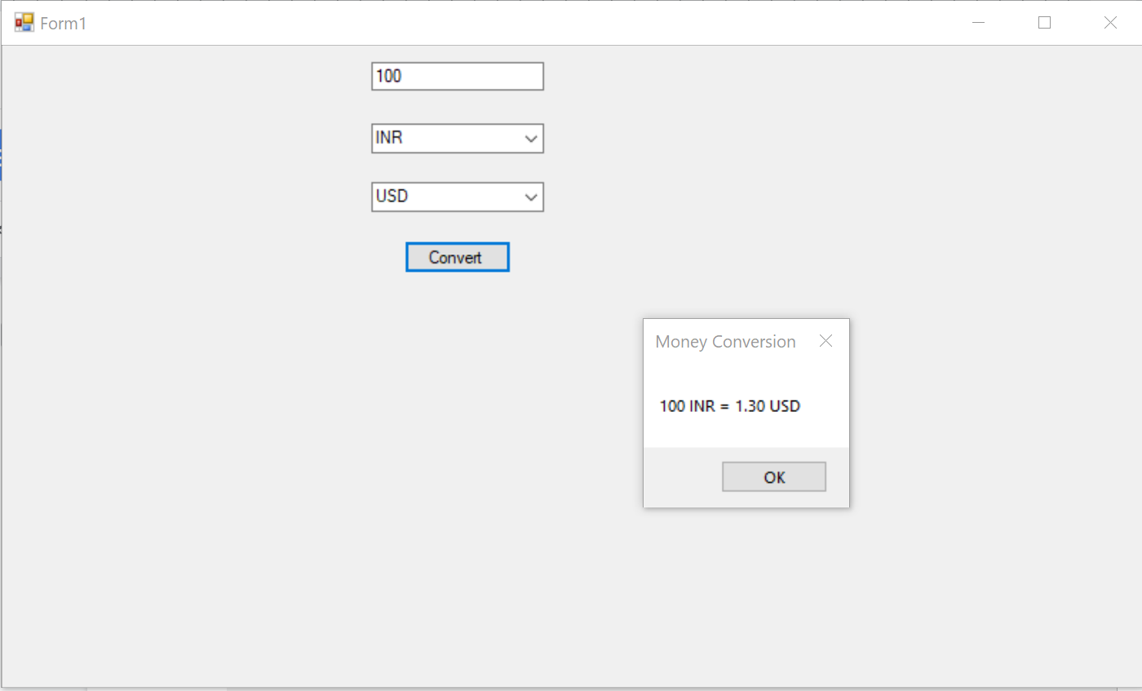

1. **To convert temperature from Fahrenheit to Celsius or vice versa.**

**SOURCE CODE:**

using System;

using System.Collections.Generic;

using System.ComponentModel;

using System.Data;

using System.Drawing;

using System.Linq;

using System.Text;

using System.Threading.Tasks;

using System.Windows.Forms;

namespace p1Temperature

{

public partial class Form1 : Form

{

public Form1()

{

InitializeComponent();

}

private void button1_Click(object sender, EventArgs e)

{

int temp = Int16.Parse(textBox1.Text);

double value = 0;

if (comboBox1.Text == "Fahrenheit")

{

value = (temp * 9 / 5) + 32;

MessageBox.Show(value.ToString(), "Celsius to Fahrenheit");

}

if (comboBox1.Text == "Celsius")

{

value = (temp - 32) * 5 / 9;

MessageBox.Show(value.ToString(), "Fahrenheit to Celsius");

}

}

}

}

**OUTPUT:**

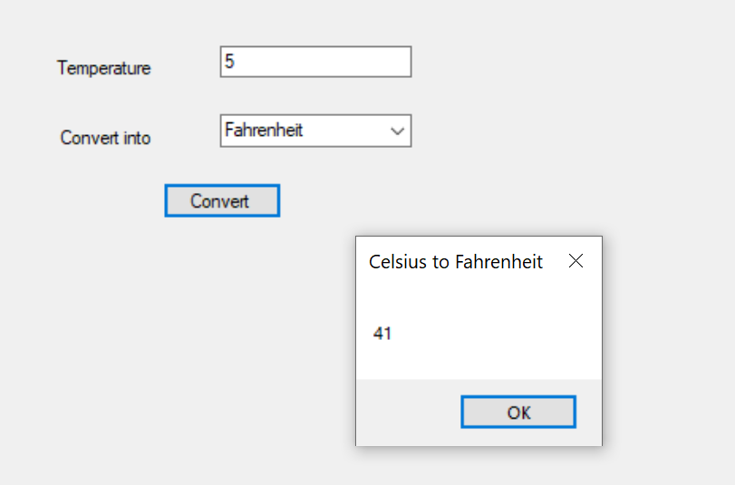

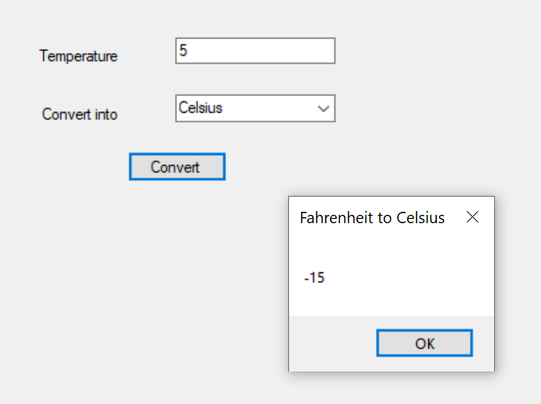

1. **Create a Window application to calculate age of a person by providing input as birth date and current date .Current date and Birth date must be in long string format and display the age in terms of years**

**SOURCE CODE:**

using System;

using System.Collections.Generic;

using System.ComponentModel;

using System.Data;

using System.Drawing;

using System.Linq;

using System.Text;

using System.Threading.Tasks;

using System.Windows.Forms;

namespace p1Birthday

{

public partial class Form1 : Form

{

public Form1()

{

InitializeComponent();

}

private void button1_Click(object sender, EventArgs e)

{

string textBox2 = Convert.ToString(DateTime.Now.ToLongDateString());

DateTime bdate = Convert.ToDateTime(textBox1.Text);

DateTime cdate = Convert.ToDateTime(textBox2);

int years = (cdate.Year - bdate.Year) - 1;

int months = 12 - Math.Abs(cdate.Month - bdate.Month);

int days = cdate.Day - bdate.Day;

MessageBox.Show("Age is :- " + years + " Years " + months

+ " Months " + days + " Days. ", "Age Calc");

}

}

}

**OUTPUT:**

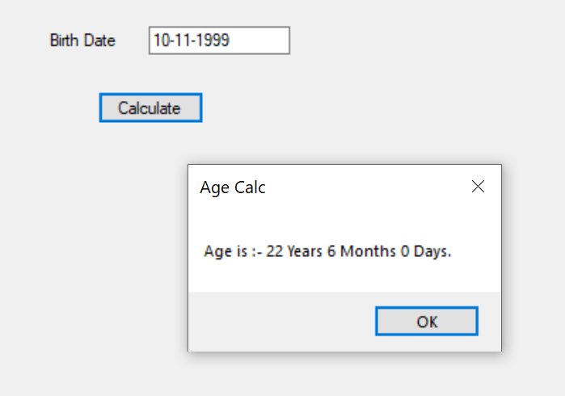

**CONCLUSION:**

From this practical, I have learned about the basics of windows forms with c#.